**Screenshots for the Assignment**

**Steps for the VC Assignment**

-To enable access for the link for DataGlacier/VC,I will need to fork it to my own GitHub.I will perform that action by clicking Fork.

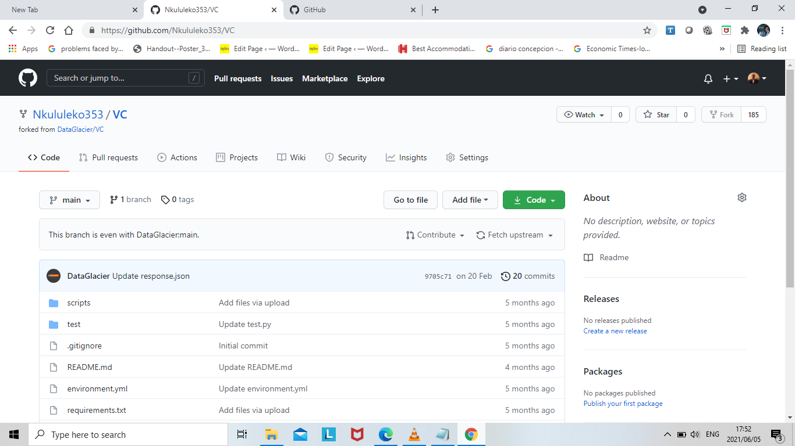

**1.Clone the VC repo (https://github.com/DataGlacier/VC.git (Links to an external site.))**

-To Clone the repository to the local system,I will need to clone if from the GitHub.I will perform this action with the use of the command as follows:**git clone https://github.com/Nkululeko353/VC.git**

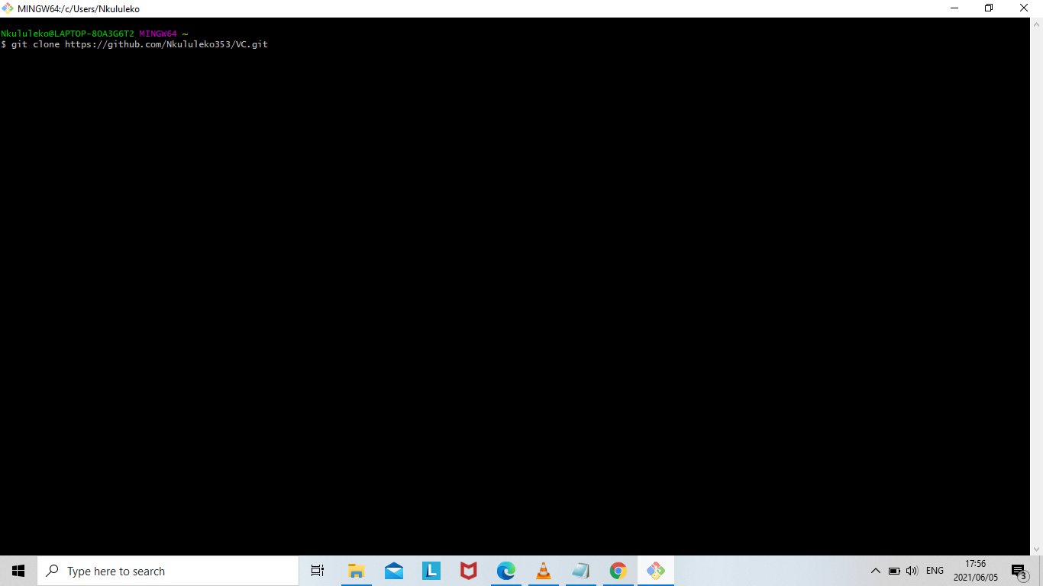

To confirm that the repository is really cloned ,it can be viewed as shown below.

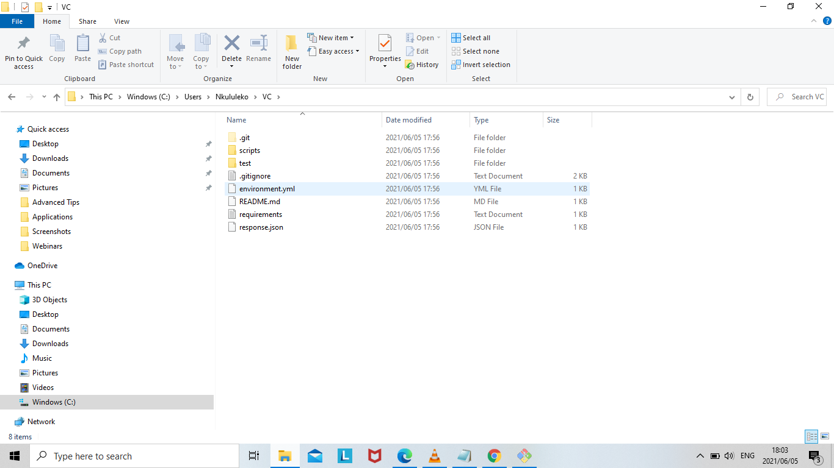

**2.Create a new branch**

**3.checkout newly created branch**

To create a new branch, this can be performed us the following command below:

**git branch main-1**

I will name the new branch as main-1.

To check out the newly created branch,this can be performed using the following command as follows:

**git checkout main-1**

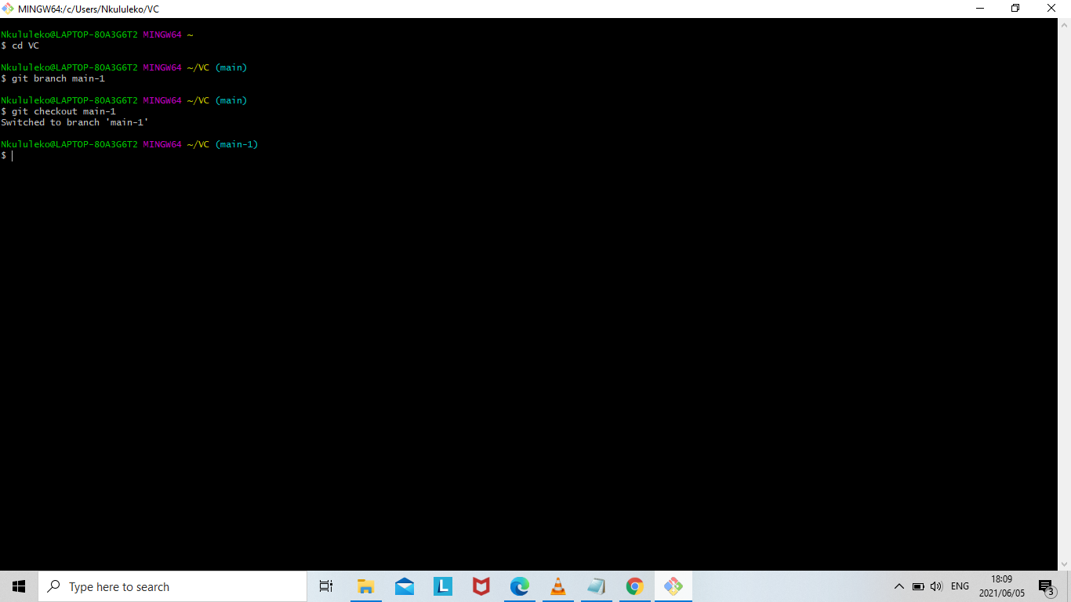

**4.Run the add.py and provide your name and fav sport as input.**

This requires a sequence of steps to accomplish the following action.

-First we run **the vi setup.py** command

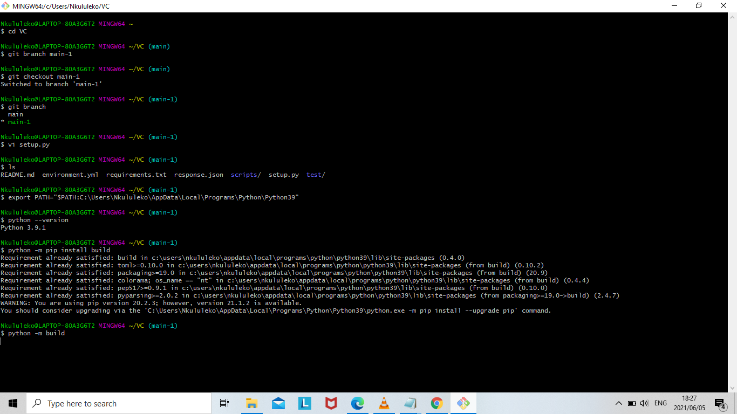

-We need to edit this file with the following programming statements as shown below.These are for the packages for python libraries.After we have edited ,we need to write the following command**:wq to** save changes.

-We write the **ls** command to show all the files available.As shown above,the setup.py file is added.

- To enable access to the Python files with all libraries and packages included there,we need to write the following command : **export PATH="$PATH:C:\Users\Nkululeko\AppData\Local\Programs\Python\Python39** " as shown above.This is where is the directory of Python file is located.

We can also check the version of python using the command **python - -version.**

**-**We need to install build using the command **python -m pip install build and** then we write the command **python -m build**.

-By running the **ls** command,we see the example_pkg_YOUR_USERNAME.egg-info file included.

-We need to change the directory by writing **cd scripts.**This is where the add.py file is located,and we need the the add.py file to run it to provide name and fav sport.To confirm that the add.py file is located in the scripts directory,we run the command **ls** and indeed the add.py file is located there.

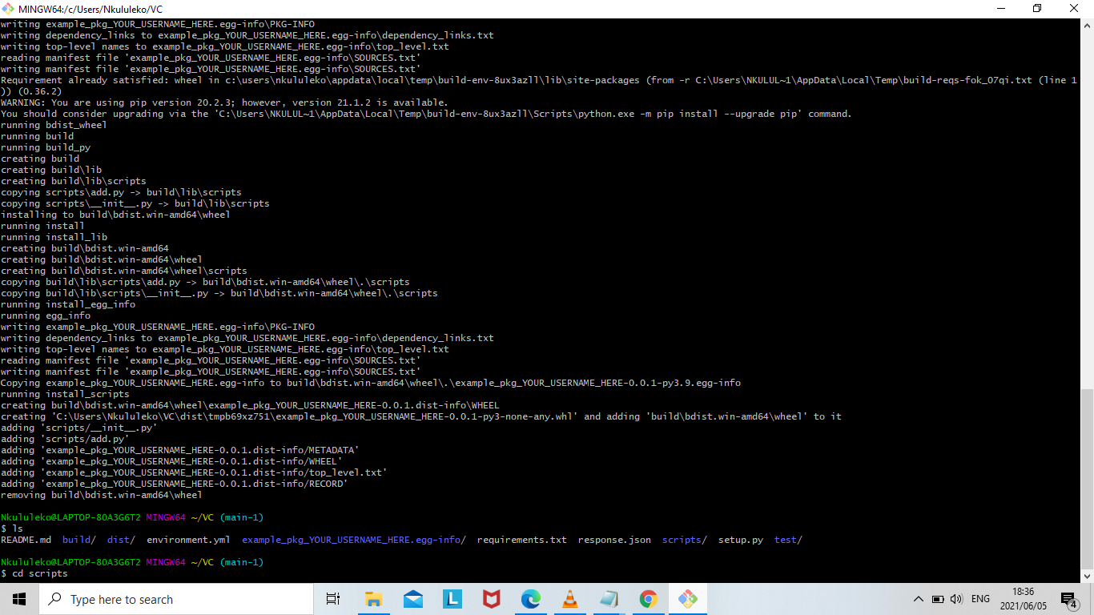

We run the **python add.py** command.After we execute this command,the command prompts for name and favourite sports name. By this we can say we’ve accomplished our goal.

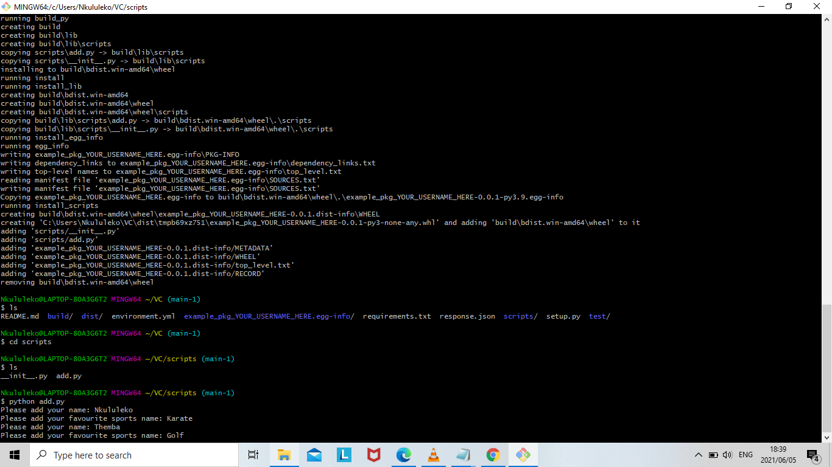

By running this following command cat response.json,we can see that what we’ve entered is shown.

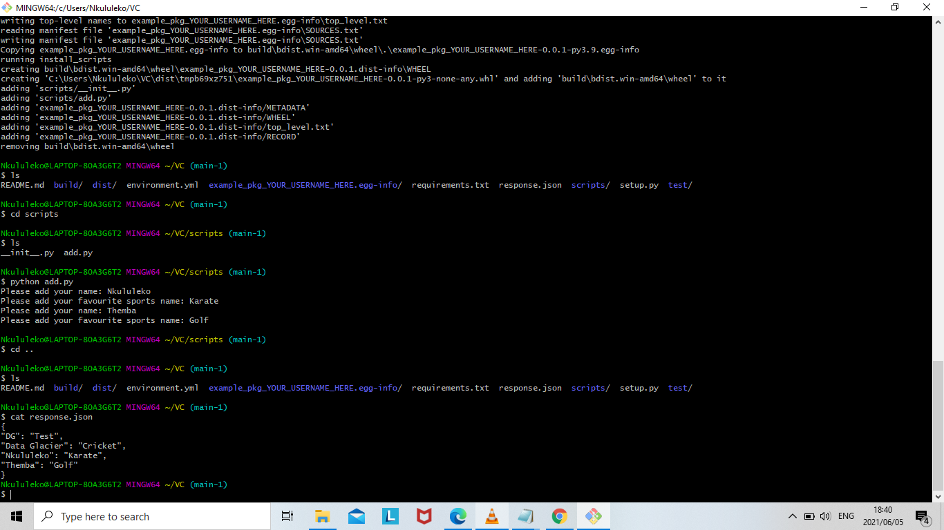

**5.Run the test script using below command:**

**pytest test/test.py -s**

-We need to change the directory to test by running the command **cd test.In the** test directory the **test.py file is available.**

**-**We can run the **vi test.py** command**.**

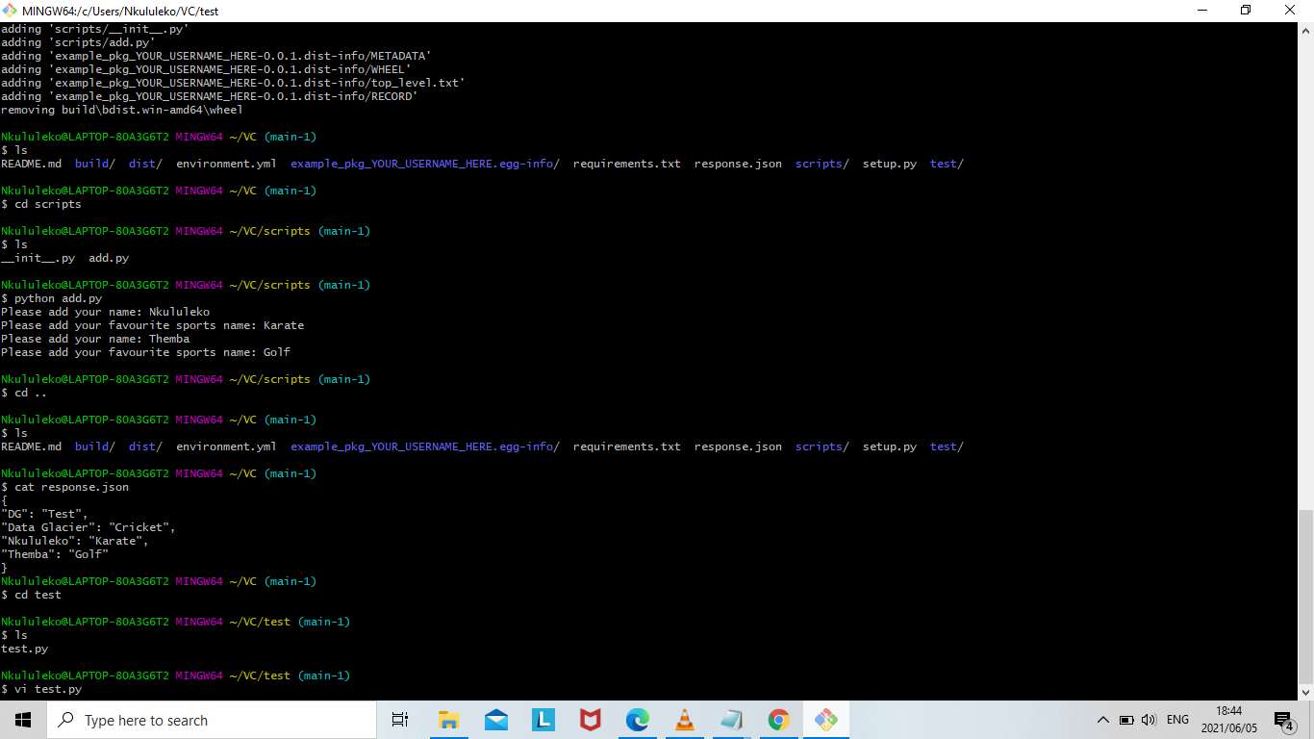

-We need to run the test script.We run the command python **test.py.**Again here we are prompted for the name and favourite sports name.

- To enable access to the pytest file,all its packages,libraries we need the directory.We need to locate the directory.

- We need to install pytest by running the following command **pip install pytest.**To check for a version we run the **pytest - -version c**ommand**.**

**-**Then finally we can **run the test script using the following command :** **pytest test/test.py -s.**

-Here we can say that we’ve accomplished our goal.

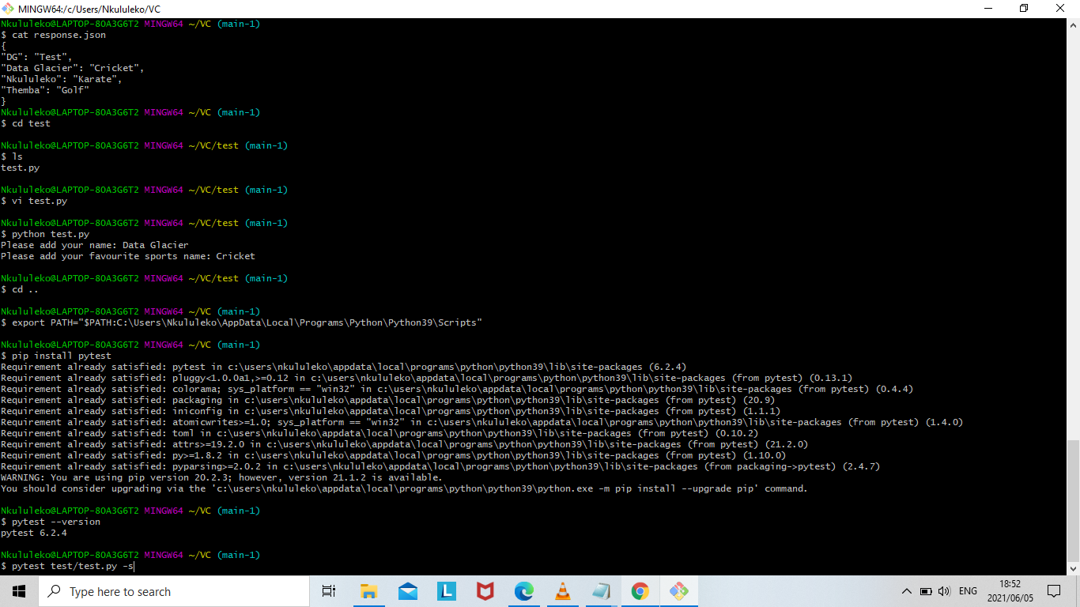

**6.Ignore warning and if there is no error then add,commit and push your changes to repo**

**create pull request and assign to reviewer.**

-To check the status of the new created branch the run the command: **git status.As shown below we can see that the response.json file has been modified.**

**To add the the file we run the command:git add response.json.**

**-To commit changes we run the command :git commit -m “added and tested response”.**

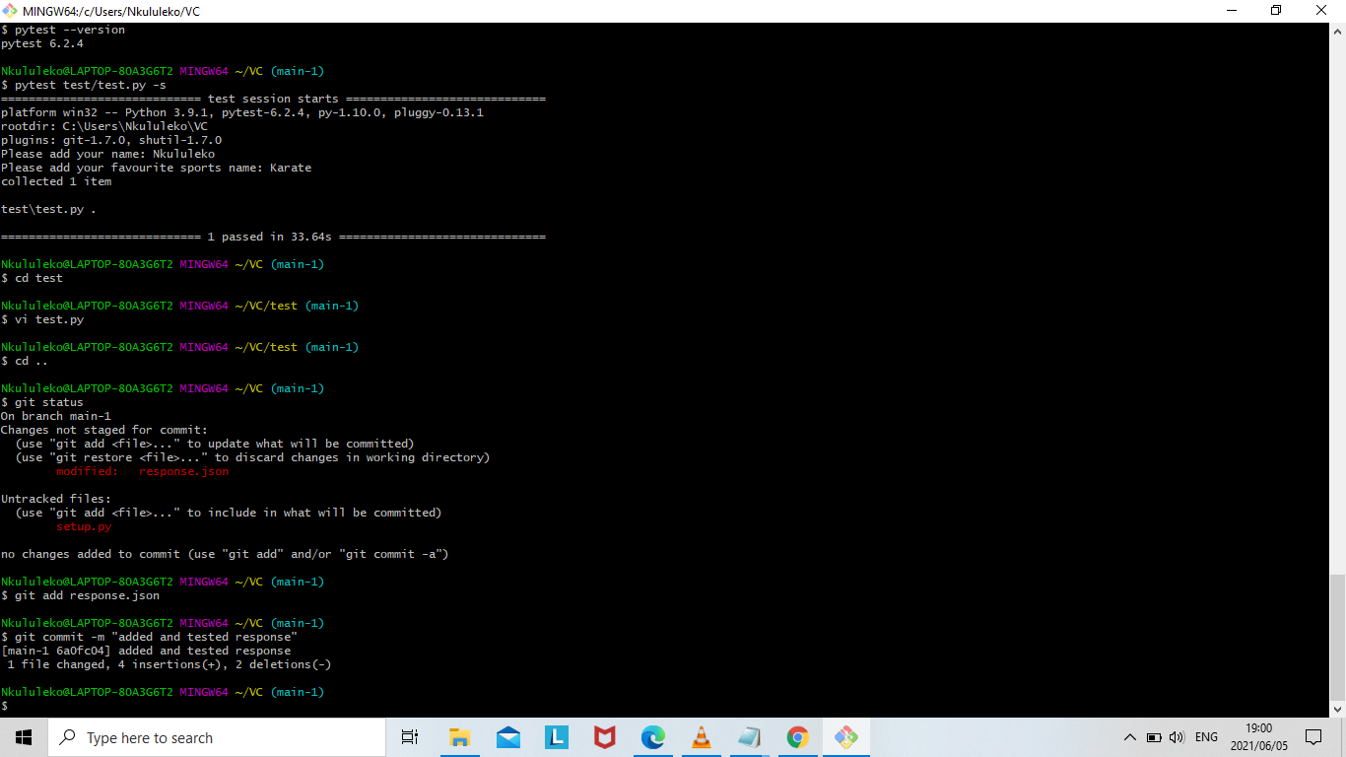

Lastly to push changes to the remote repository we run the command:git push - -set-upstream origin main-1

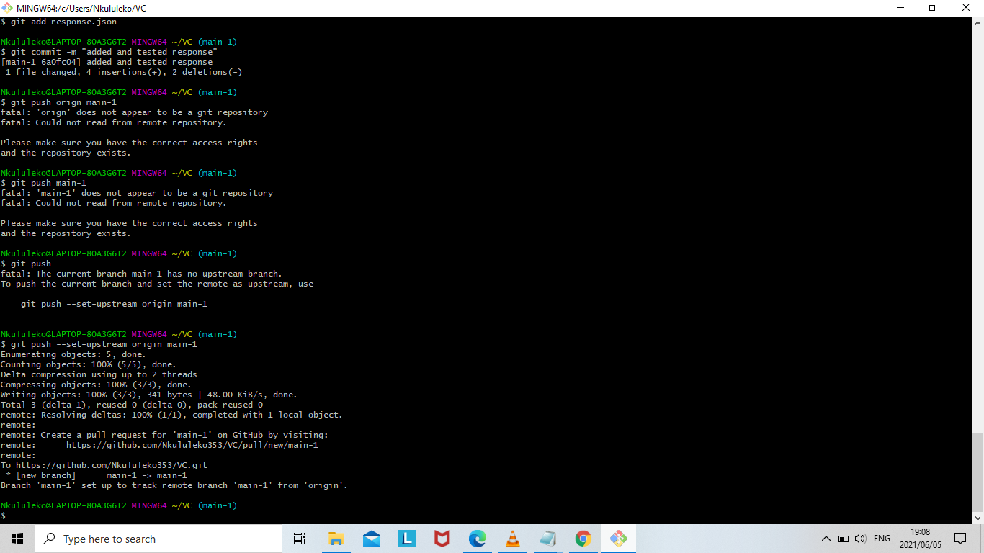

To really confirm that that the changes are pushed,this is what we see.We see that the new branch is included,**main-1.**

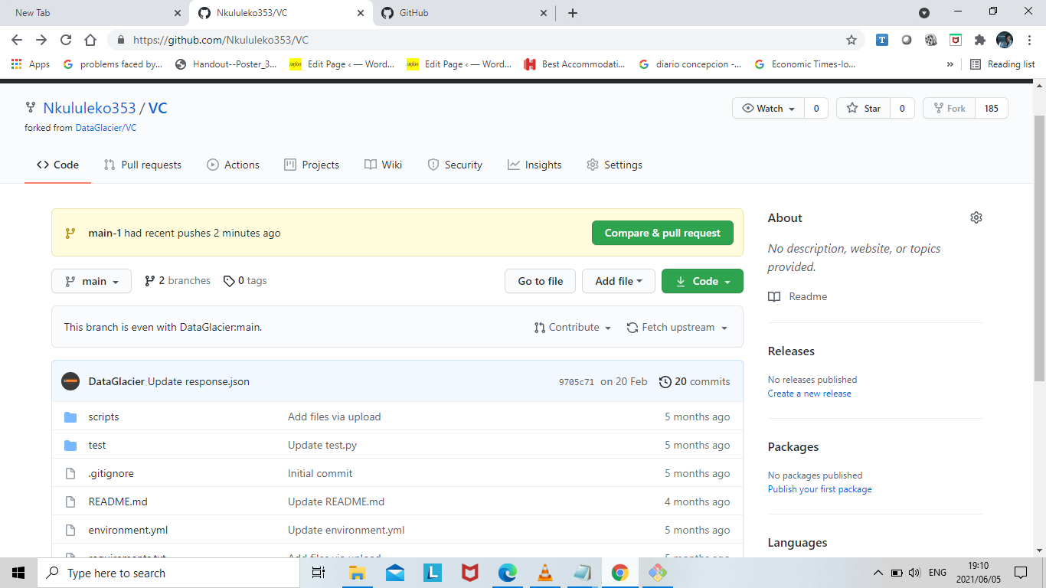

**create pull request and assign to reviewer**

**If reviewer approves then merge the changes to master.**

We can create a pull request by comparing the base:main with the main-1 branch and leave a comment.

